Accessibility at Dutton Park to Salisbury stations

The Project

What is Cross River Rail?
Cross River Rail is a new underground train line in Brisbane that will transform the way we travel across South East Queensland. CRR will deliver:
- 10.2 kilometres new rail line from Dutton Park to Bowen Hills
- 5.9 kilometres twin tunnels under the Brisbane River and CBD
- 4 new underground stations at Boggo Road, Woolloongabba, Albert Street and Roma Street
- 3 new stations on the Gold Coast at Pimpama, Hope Island and Merrimac
- 8 upgraded stations - Salisbury, Rocklea, Moorooka, Yeerongpilly, Yeronga, Fairfield, Dutton Park and Exhibition
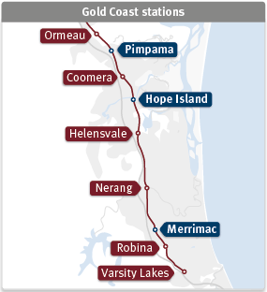
Figure 1 - Map of Gold Coast stations, with existing stations from Varsity Lakes to Ormeau and new stations Pimpama, Hope Island and Merrimac
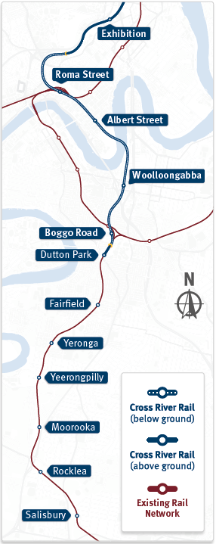
Figure 2 - Map of Cross River Rail new and upgraded stations, and new Cross River Rail below and above ground track

Cross River Rail and Accessibility

Why is accessibility important?
- Almost 20% of Queenslanders (1 in 5) have a disability
- 5.8% have severe or profound disability
- Of those with a disability living in households 40.9% use public transport
- People are living longer – at 65 years of age Australians can expect to live half of their remaining years with some level of disability
- 375,000 people who are blind or vision impaired currently living in Australia
- 4.4% of people with a disability in Australia use a wheelchair
- 3 million people live with depression and/or anxiety
- Over 1 million Australians with disabilities report difficulties with public transport.
Common reasons include:
- 42% issues getting in or out of the vehicle
- 31% getting to stops or stations
- 23% experience feelings of fear or anxiety
- 21% lack of seating or difficulty standing
“We want to ensure that customers have a positive experience with Cross River Rail, during construction and once it is in operation. Creating spaces that are functional, inclusive and accessible is a crucial part of what we do and something we are 100% committed to” said Graeme Newton, Chief Executive Officer, Cross River Rail Delivery Authority (CRRDA)

The Cross River Rail commitment
Cross River Rail will deliver a piece of infrastructure that is Integrated, accessible and inclusive.

Our guiding principles
To guide Project elements in relation to accessibility and inclusion, the Accessibility Plan is founded on four key principles:
- Building stations and systems for all: Provide stations that are accessible and easy to use for everyone
- Every customer experience enhanced: Provide every customer access to the information and tools they need to have a better customer experience
- Integrated and connected into the network: Ensure Cross River Rail is a seamless connection into the existing network, connecting more people, more often
- Work together collaboratively: Work with those who know, to understand how best we can reduce barriers and create inclusive journeys

Accessibility Reference Group
To ensure we work with those who know, to understand how best we can reduce barriers and creative inclusive journeys, the Cross River Rail Accessibility Reference Group (ARG) was established in May 2020. The group includes representatives from the disability sector and individuals with lived experience across a range of areas including, physical, cognitive, sensory, life stage and situational disabilities. Engagement throughout all stages of project delivery aims to:
- Provide an inclusive and accessible forum to engage with a range of disability sector representatives where they can share their lived experience to inform and improve project outcomes
- Collaborate with and embed Queensland Rail (QR), Department of Transport and Main Roads (DTMR) and CRRDA accessibility experts throughout the process
- Facilitate direct engagement and two-way communication between disability sector representatives and technical experts
Through these engagement activities the Cross River Rail Project (the Project) identifies critical pain points and opportunities to improve accessibility outcomes.
The Project will continue to include representatives of the disability sector throughout each stage of project delivery, engaging with the sector from the earliest stages of concept design through to detailed design and construction.
“The early stakeholder engagement activities facilitated by the CRRDA has allowed me as the Lead Architect to genuinely understand the needs of communities including those with specific access requirements. This understanding has led to best practice in accessible design outcomes that increase the capacity for all people, communities and our city to thrive” said Tanya Golitschenko, Architecture Team Lead, Unity Alliance.

Integration
Cross River Rail will be part of a wider public transport network connecting South East Queensland. It is important that customers not only have a positive experience using new infrastructure, but that there is consistency across the network to support seamless and inclusive journeys. The CRRDA works hand in hand with Department of Transport and Main Roads (DTMR) and Queensland Rail (QR) to support this endeavour.
These agencies are involved throughout the consultation process and provide insights on accessibility findings and outcomes to ensure consistent and connected journeys now and into the future.
“It is actually good to know the staff in the room hear what we say and take it on board. We now don’t seem to have as many questions as staff are starting to be more aware of the issues” said Robert Plant, Accessibility Reference Group member.

Dutton Park to Salisbury
Seven stations on Brisbane’s southside – Salisbury, Rocklea, Moorooka, Yeerongpilly, Yeronga, Fairfield and Dutton Park – will benefit from accessibility rebuilds as part of the Cross River Rail project.
The Dutton Park to Salisbury stations vary in age and represent a spectrum of barriers to inclusive and accessible travel for passengers with a disability. Of note, some stations possess no lift access and limited or insufficient station amenities.
These southside station upgrades include new footbridges and passenger lifts, accessible parking bays, new kiss ‘n’ ride spaces and extensive platform height and access improvements.
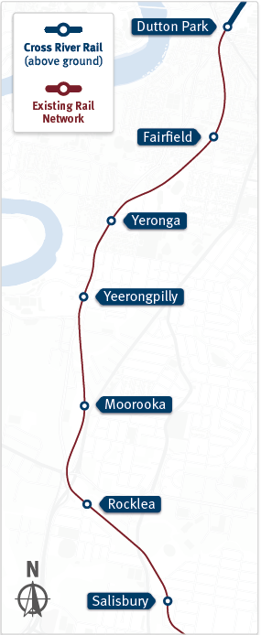
Figure 3 - Map of Dutton Park to Salisbury stations that will be receive accessibility upgrades as part of the Cross River Rail project, including Dutton Park, Fairfield, Yeronga, Yeerongpilly, Moorooka, Rocklea and Salisbury

Dutton Park to Salisbury accessibility design process:
- Consultation: ARG participants are introduced to station concept designs and identify issues requiring further investigation.
- Exploration: The Project team, in collaboration with project partners (QR and DTMR), explore identified issues. A working group may be established to discuss complex issues with disability sector members. This ensures all stakeholders understand the needs and concerns of the target group and a variety of solutions are evaluated.
- Resolution: Working Group recommendations are taken to the appropriate decision makers for consideration. The consultation loop is then closed and reporting of solutions issued to the ARG members.
- Implementation: Solutions are endorsed by ARG and applied to existing and future designs as best practice.

What features will be included in the rebuilt stations?
Upon completion, all stations from Dutton Park to Salisbury will have the following features:
- Additional third platform at high-level and existing platforms raised to high-level
- Reduced platform gap and two dedicated boarding assistance points per platform
- Rest stops (bench seating with arm rests) at least every 60m along platform
- New station buildings with unisex accessible toilet, ticket counter, vending and ticketing machines
- Accessible toilets will include the following features:
- Grab rails and backrest
- Large flush buttons
- Assistance call button and light
- Colour contrast to seat, rails, buttons, backrest, door hardware and fixtures
- Baby change table
- Hearing Aid Loop
- Help Phone and Next Train Information (NTI) device located at both entrance points and core boarding zone
- TGSI paths to stairs and platform edge
- Braille and tactile signage at information and key decision points
- High contrast surfaces on:
- Stair nose strip
- Handrails
- TGSI
- Kerb ramps
- Accessible toilet doors and flush buttons
- Step ramps
- Lift doors signage
- Vertical to horizontal surface transitions
- Increased Hearing Aid Loop (HAL) coverage, including at ticket window, accessible toilet and core zone
- CCTV and lighting throughout stations

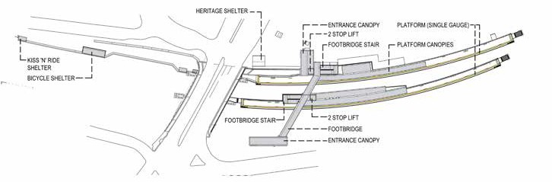
Dutton Park
Figure 4 - Dutton Park birds-eye view station design with station features as listed below
- Two new through lifts, two new stairs and a footbridge
- Two new accessible parking spaces on Kent Street
- Upgraded complaint road crossing to Kent Street
- Improved, accessible connection to the bus stop on Noble Street
- 40% canopy coverage including to the platform core zone, footbridge, stairs and station entries
- 80% of covered areas include HAL coverage
- Two wheelchair waiting spaces at every priority seat location, including core zones, kiss ‘n’ ride and rest waiting areas
- One ambulant male, one ambulant female and one unisex accessible toilet located in the station building on the inbound platform (toward the City)

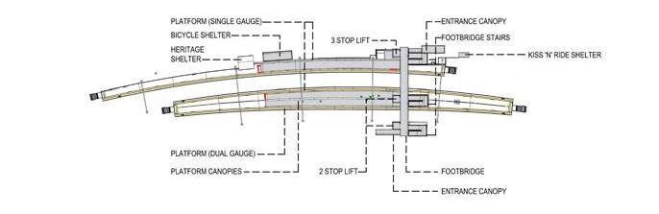
Fairfield
Figure 5 - Fairfield birds-eye view station design with station features as listed below
- Two new through lifts (Equity Street lift includes mirrors) and one turn around lift with mirrors to Mildmay Street
- Three stairs and footbridge
- Two new accessible parking spaces on Equity Street
- New compliant road crossings at both station entrances
- 40% canopy coverage, including platform core zone, footbridge and station entries
- 80% of covered areas include HAL coverage
- Two wheelchair waiting spaces at every priority seat location, including core zones, kiss ‘n’ ride waiting area
- Unisex accessible toilet located in the station building on the inbound platform (toward the City)

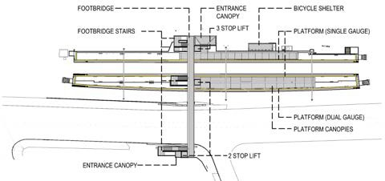
Yeronga
Figure 6 - Yeronga birds-eye view station design with station features as listed below
- Three new through lifts (Lake Street lift includes mirrors), three stairs and footbridge
- Two new accessibility parking spaces on Lake Street
- New compliant road crossings at both station entrances
- 40% canopy coverage, including platform core zone, footbridge and station entries
- 80% of covered areas include HAL coverage
- Two wheelchair waiting spaces at every priority seat location, including core zones, kiss ‘n’ ride waiting area
- Unisex accessible toilet located in the station building on the inbound platform (toward the City)

Yeerongpilly
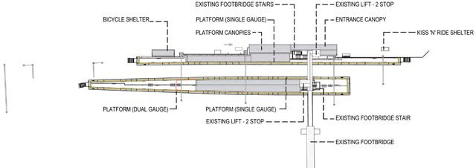
Figure 7 - Yeerongpilly birds-eye view station design with station features as listed below
- Two existing through lifts and one existing turnaround lift, two stairs and footbridge
- New stair and ramp to platform 1
- Two new accessible parking spaces on Wilkie Street
- New compliant road crossing on Wilkie Street
- 40% canopy coverage, including platform core zone, footbridge, station entries, and between station entry and bus stop on Wilkie Street
- 80% of covered areas include HAL coverage
- Two wheelchair waiting spaces at every priority seat location, including core zones, kiss ‘n’ ride waiting area
- Unisex accessible toilet located in the station building on the inbound platform (toward the City)

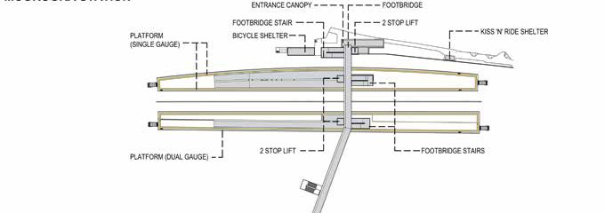
Moorooka
Figure 8 - Moorooka birds-eye view station design with station features as listed below
- Three new through lifts, three stairs and footbridge
- Two new accessible parking spaces on Ipswich Road
- Existing signalised crossing to cross Ipswich Road
- 40% canopy coverage, including platform core zone, footbridge and station entries
- 80% of covered areas include HAL coverage
- Two wheelchair waiting spaces at every priority seat location, including core zones, kiss ‘n’ ride waiting area
- Unisex accessible toilet located in the station building on the inbound platform (toward the City)

Rocklea
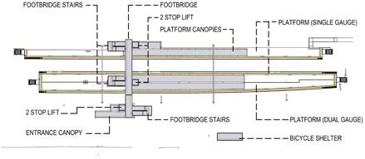
Figure 9 - Rocklea birds-eye view station design with station features as listed below
- Three new through lifts, three stairs and footbridge
- Two new accessibility parking spaces in park ‘n’ ride car park accessed via Brookes Street
- New road crossing on Pegg Road
- 40% canopy coverage, including platform core zone, footbridge and station entries
- 80% of covered areas include HAL coverage
- Two wheelchair waiting spaces at every priority seat location, including core zones, kiss ‘n’ ride waiting area
- Unisex accessible toilet located in the station building on the inbound platform (toward the City)

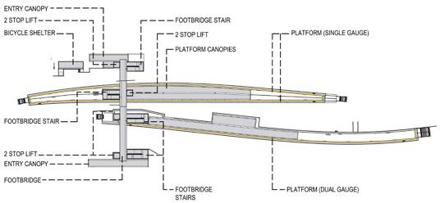
Salisbury
Figure 10 - Salisbury birds-eye view station design with station features as listed below
- Two new through lifts and two turnaround lifts with mirrors, four stairs and footbridge
- 2 new accessible parking spaces on Dollis Street
- 80% of covered areas include HAL coverage
- 60% canopy coverage to platform 3, and 40% canopy coverage to Platforms 1 and 2
- Two wheelchair waiting spaces at every priority seat location, including core zones, kiss ‘n’ ride waiting area
- Unisex accessible toilet located in the station building on the inbound platform (toward the City)

Accessibility engagement

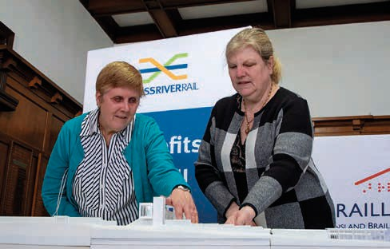
Engagement tool – 3D Tactile Models
Figure 11 - Two vision impaired stakeholders get an assisted birds-eye view of the station and passenger-facing amenities via a 3D Tactile Model to explore Fairfield station from the point of view of persons using a cane or Guide Dog.
A 3D Tactile Model of Fairfield station was printed following consultation with Accessible Reference Group members with low or no vision, Braille House, Link Vision and the Project design team. The 3D model gave low or no vision stakeholders a birds-eye view of the station and passenger-facing amenities to explore the station from the point of view of persons using a cane or Guide Dog. This exploration informed design changes including the placement of key elements such as seating, ticket offices and Tactile Ground Surface Indicators (TGSI) at Fairfield station. The Project is continuing this process for other southern area stations.
“We have worked closely with stakeholders such as Braille House to design innovative inclusive design tools which enabled a wider faction of transport users to experience the station designs and provide comment” said Tanya Golitschenko, Architecture Team Lead, Unity Alliance
“The innovative use of this 3D tactile model is demonstration of Cross River Rail’s commitment to working with everyone in the community on the station concept designs” - Braille House

Wayfinding Engagement
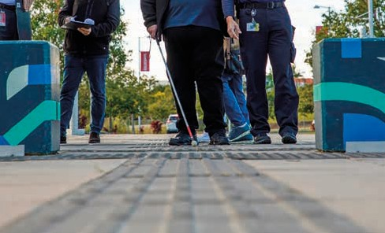
Working groups made up of subject matter experts and people with lived experience of low and no vision advocate for wayfinding to be consistent across all transport networks in Australia, in particular TGSI and tactile signage. As a result the Project applied a consolidated approach across packages of work under the Project, resulting in consistent, logical and predictable wayfinding outcomes for future customers using all 15, new and upgraded Cross River Rail stations.
Figure 12 - Visually impaired stakeholder experiences TGSI paths during a site visit to Varsity Lakes station in order to provide feedback into new station designs.
“It’s important to be part of the reference group so that these stations can be as accessible as possible for every person in the community. It is really positive that no idea is off limits, and we can all work together for a common good outcome” said Paul Thorburn, Independent Accessibility Reference Group member.

Site visits
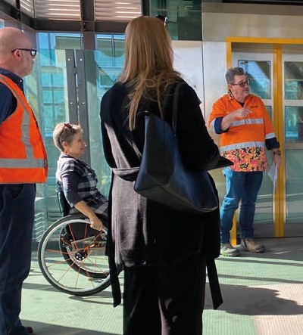
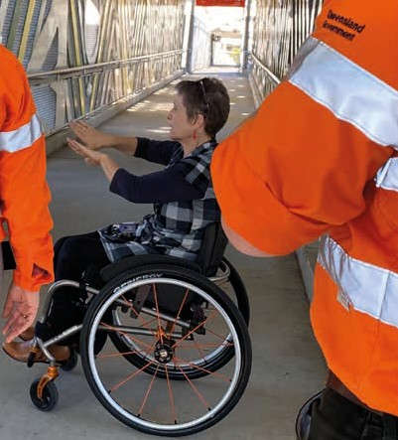
Project designers and Accessibility Reference Group members attended a site visit to Yeerongpilly station for context and understanding of the difficulties in accessing information and to explore visual alternatives.
Figure 13 - Stakeholders and decision makers attend site visit to Yeerongpilly with wheelchair users to gain insights for improvements to station designs.
Figure 14 - Stakeholders attend site visit at Yeerongpilly with wheelchair user to gain experience insights for improvements to new station designs.
It was agreed that digital displays and functionalities should be accessible to ensure all people can fully engage with new and upgraded CRR stations, and new and upgraded stations.
Implementation will include placement of digital display screens to limit glare at all times of the day, and improved lift emergency button functionality and clearer visual cues to assist in emergencies.

Lift Engagement
Accessibility upgrades at Dutton Park to Salisbury stations on the Beenleigh line include the addition of a total of 18 lifts across the seven stations. Installing lifts at stations which have previously only been accessible by stairs, allows customers with varying levels of mobility to utilise the station.
Consultation: Through regular monthly engagement with ARG, accessible lifts emerged as a topic of interest for several members.
A lift working group was formed as a vehicle to achieve best practice lift outcomes for Cross River Rail and South East QLD. The working group included representatives with low or no vision or hearing, and those with varying degrees of physical mobility in the upper body who use a manual wheelchair or motorised scooter.
Exploration: An initial brief from the Unity Alliance contracting team outlined the number, location, and function of the lifts to be installed. Working group members provided feedback directly to the project team, recommending potential innovative solutions to optimise lift functionality for diverse user groups.
The working group, made up of ARG members, contractors and project staff, visited Yeerongpilly station (a station on the Beenleigh line) to test the existing lifts. The site investigation supported discussions of potential lift improvements in the context of a local and live station environment.
Resolution: The key themes that emerged from engagement activities included:
- Installing through lifts allows easier lift entry and exit, and minimises the need to reverse out of a lift if using a wheelchair
- Where site constraints prohibit the use of through lifts, installing a convex mirror in a turnaround lift provides a good line of site for a person reversing in a wheelchair
- Larger circulation space in lifts is preferred
- Designing stations with offset stair and lift entrances can enhance safety
- The number and placement of lift control buttons is important - locating buttons away from hard-to-reach corners and on both sides of the lift car is preferred
- Including large clear signage with appropriate braille and tactile letters is important
- Including audible announcements in lifts, which correspond to visual signage ensures those with low or no vision don’t miss out on information (e.g. audible announcement when the lift reaches its destination, or in the event of an emergency)
- Ensuring functionality has sufficient visual equivalents to support users
- Increasing visibility with clear lift door panels to improve sightlines from a standing or seated position
Implementation: From these recommendations, there have been upgrades to the primary access point lifts at Moorooka, Rocklea, and Salisbury stations to through lifts.
All other recommendations will be enacted where possible through design and implementation.

Train Access Engagement
Station redevelopments on a curved platform introduces many challenges in relation to platform and train interfaces. Therefore, minimising the gap between train carriage and platform is a crucial element of the Dutton Park to Salisbury station accessibility upgrades to enable efficient and independent train access.
Consultation: A train access working group was established to investigate methods in minimising the gap between platform and train carriage so far as reasonably practicable.
The working group included disability sector representatives of varying ages, including those with low or no vision or hearing, and members with varying degrees of physical mobility in the upper body who use a manual wheelchair or motorised scooter.
Exploration: The train access working group met from September through October 2020 with aims to:
- Learn about site conditions at Dutton Park to Salisbury stations that create a gap between platform and train carriage
- Better understand the user experience of train access from platform to carriage
- Identify and explore innovative solutions to reduce the gap between platform and train carriage as much as possible
- Understand and recommend infrastructure outcomes and operational procedures that enable greater train access
An initial brief was provided to outline existing station conditions and the plan to raise the level of the platform to reduce the vertical platform gap as much as possible.
A platform gap prototype was developed and tested by working group members to simulate a real station environment, demonstrating train access with a variety of gap widths for diverse user groups. Members were then surveyed about their experience.
A rubber platform gap filler was proposed to reduce the horizontal gap further. A visit to Narangba station allowed members to test and provide feedback on a rubber gap filler prototype in a local, live station environment.
Resolution: Outcomes of train access engagement identified and endorsed:
- Preference for reducing the vertical platform to train carriage step-gap as a primary priority
- Preference for reducing both the vertical and horizontal platform to train carriage gap as much as possible
- Use of a rubber gap filler to reduce the platform to carriage gap even further, beyond what existing station constraints permits
- The ongoing requirement to maintain boarding assistance in the accessible core zone at Queensland Rail stations
Implementation: From this engagement, the recommended solutions will be implemented to improve train access. The proposed outcomes will, in most instances, reduce the vertical height to below 12mm improving boarding gradient. However, some customers may still require operational assistance through the deployment of a manual or automatic boarding device.

Lessons Learnt
Engagement with ARG members and the broader community has been extremely valuable in informing improvements in station design. It promotes a human-centric approach to design concepts, and ensures compliance is not just a box-ticking exercise but an effort to meet and exceed standards for a positive customer experience.
Timing is everything: The process of accessibility design must be embedded as soon as practical to ensure experience and prior learnings are captured early in the project and inform design thinking from the outset.
Equitable consultation: Ensure an equitable consultation approach, by considering diverse needs of participants. Briefing materials should be in a format that accommodates the participants needs in order to inform for fair and equitable consultation e.g. 2D or 3D models for participants with low or no vision.
Consistency is key: Passengers seek commonalities at stations, as ‘shortcuts’ for understanding layouts or functionality. While localised variation is inevitable in existing environments, adopting overarching strategies that can be replicated will be efficient and effective long term, and result in a better customer experience.
There is no such thing as ‘too much communication’: Feedback loops are invaluable in keeping participants (in consultation) updated. Issues raised in consultation are often important to participants. Therefore, updates and progress reports are crucial in maintaining positive sentiment.
Customers, as the end-user, are the primary focus in design: Through engagement with subject matter experts and people with experience, there is a greater emphasis on anecdotal and scenario- based justification for design. This allows for greater authenticity in the final design, as it considers behaviours, attitudes, emotional responses, and other ‘in-the-moment’ customer experiences. Through this, the Project employs human-centric design.
“We now have real and measurable understanding of the many access needs within our communities and have designed above and beyond standards and codes; the Cross River Rail stations have set a sustainable future benchmark for accessible station architecture in Queensland and I am proud that my vision of a transport system that ‘leaves no one behind’ is underway” said Tanya Golitschenko, Architecture Team Lead, Unity Alliance.

For more information
Call: 1800 010 875
Email: info@crossriverrail.qld.gov.au
Visit webpage: crossriverrail.qld.gov.au

